1. **Latest report at the top**
2. **Coming soon**
3. **Interactive Report Card**
4. **Featured Results**:

[4](https://nationsreportcard.gov/reading_math_2015/" \l "mathematics?grade=4)[th](https://nationsreportcard.gov/reading_math_2015/" \l "mathematics?grade=4) [and 8](https://nationsreportcard.gov/reading_math_2015/" \l "mathematics?grade=4)[th](https://nationsreportcard.gov/reading_math_2015/" \l "mathematics?grade=4) [Grade Math Scores Dip in 2015](https://nationsreportcard.gov/reading_math_2015/" \l "mathematics?grade=4)

After a decade of fairly steady gains, math scores for both fourth- and eighth-grade students fell in 2015 compared to 2013.

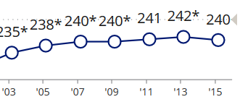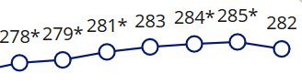

1. **Contextual variables** (this text will change every month or two?): In 2014, 66 percent of eighth-grade students said they study technology or engineering topics in science class. Learn more…
2. **Featured Sample Question**:

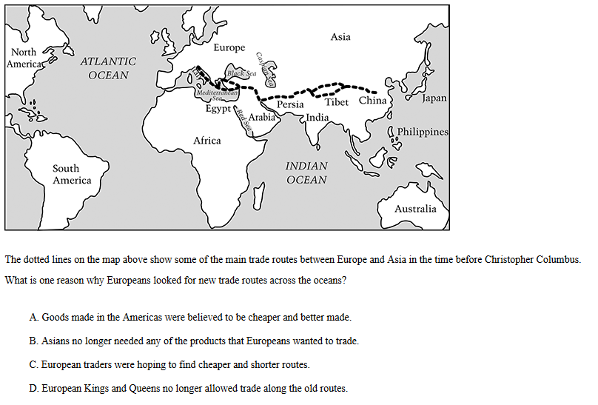

1. **NAEP in the news**
2. **NAEP on Twitter**:

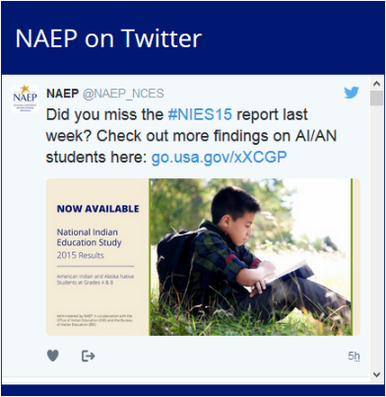

1. **NAEP Blog**:



1. **Recent Research on NAEP**:

**RECENT RESEARCH ON NAEP**

[Computer Familiarity and Digital-Based Assessments](http://www.air.org/resource/computer-familiarity-and-its-relationship-performance-three-naep-digital-based-assessments)

[Comparing NAEP and PISA Mathematics](http://www.air.org/resource/comparison-study-program-international-student-assessment-pisa-2012-and-national-assessment)

[NAEP and Preparedness for College and Job Training](https://www.nagb.org/content/nagb/assets/documents/what-we-do/preparedness-research/NAGB-indicator-of-preparedness-report.pdf)



1. **Stat topics**: What does *statistically significant* mean?
2. **NAEP Tools**:

Check out the new NAEP Data Explorer

to examine assessment results for various subjects, grades, and jurisdictions. The NDE allows you to create custom statistical tables, graphics, and maps using the NAEP data that interests you most. Play the into video >>>>>>>>>>>>>>>>>>>>>>>>>>

